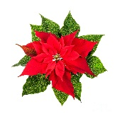
Christmas Poinsettias!!!
If you would like to purchase a Poinsettia in memory or in honor of someone, please provide the following information along with payment of $15.00 (checks payable to First Church) and the Poinsettia is yours! These can be taken home after the Christmas on Sunday, December 29th, for your enjoyment or to share with a loved one.

Given by:______________________________________________________________________

In Memory or Honor of:_________________________________________________________

Your request and payment can be placed in the Collection Plate on Sunday
or call Helen Goss at 603-520-6891 to make other arrangements.

DEADLINE TO ORDER IS FRIDAY, DECEMBER 20th.

